**Doctor Management**

**IT17179386 – Jayasuriya K.E**

**Insert details like this**

**Doctor ID -:** DOC101

**Hospital Name -:** Kandy

**Doctor Name -:** Sunil

**Age -:** 45

**Specialization -:** Kidney

**Arrive time -:** 7.00PM

**Leave time -:** 8.00PM

**Insert Doctor**

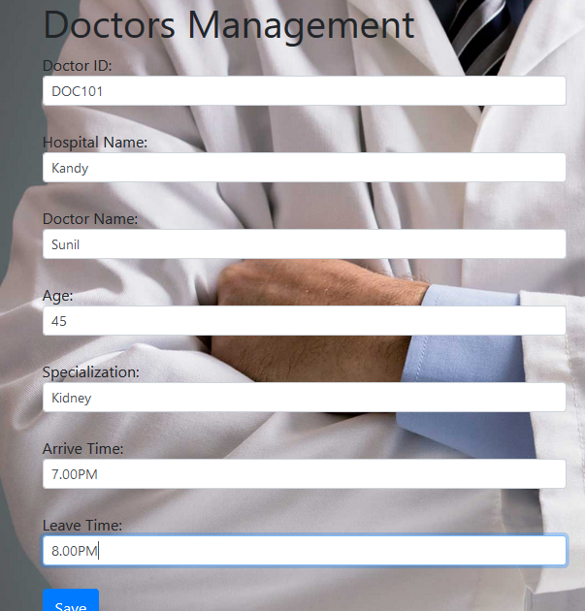

**List view after inserted value**

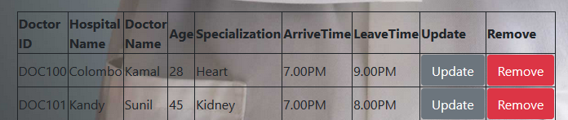

**Update selected doctor**

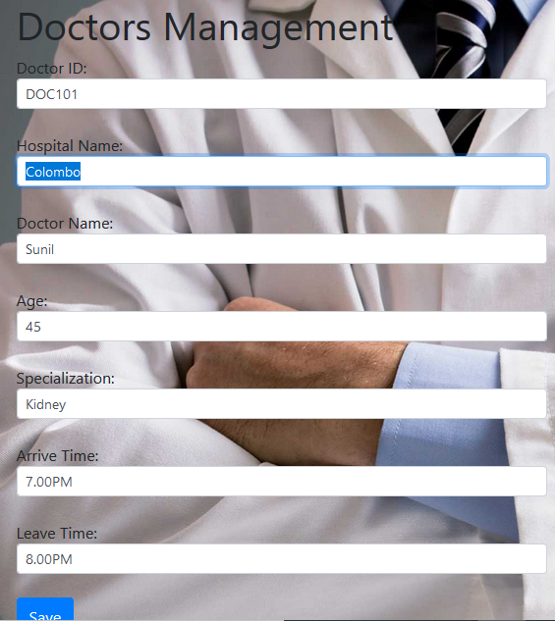

**List view after update a doctor**

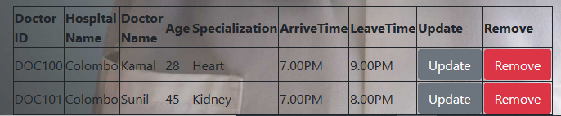

**Delete selected doctor**

